Checking TCP/IP settings

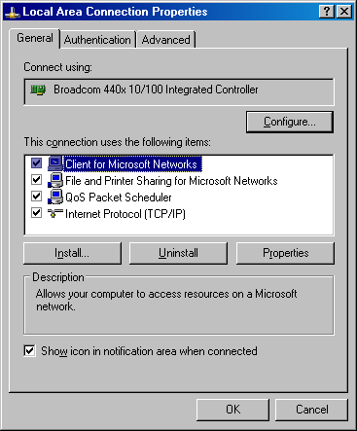
In this module we will be covering checking TCP/IP settings in Windows 98, ME, 2000 and XP.

(REMEMBER THAT IF YOU GO TO CHANGE SETTINGS ON A GUESTS SYSTEM YOU NEED TO HAVE THE GUEST AGREE TO THE DISCLAIMER)

Windows 98 and ME

To access the TCP/IP settings in Windows 98 you need to do the following:
Click on start and go to settings control panel.

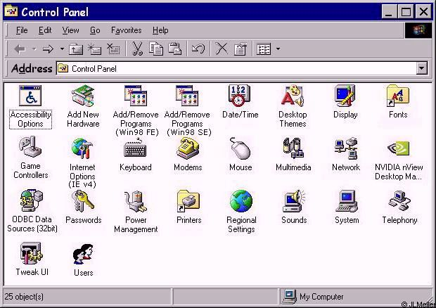

Once in control panel you need to go to Network.

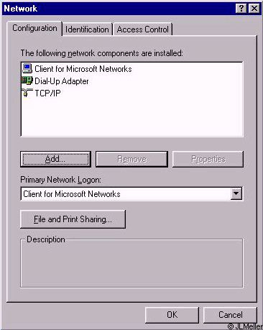

You have the guest highlight (one mouse click) TCP/IP and then have the guest do to properties.

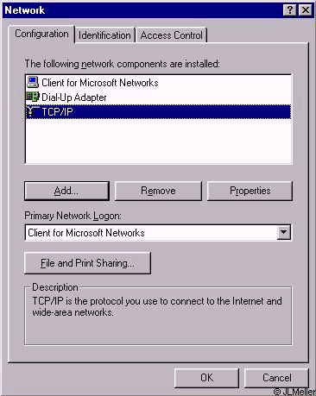
Once you have the guest on the properties page you need to make sure that the following screens are set as you see them.

The IP address Tab
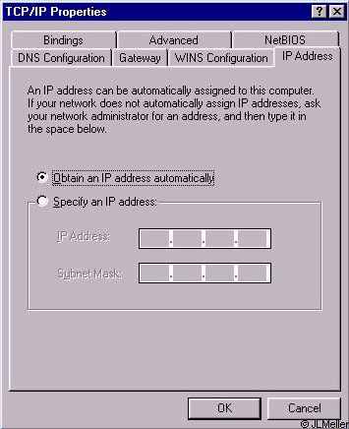

WINS Configuration Tab

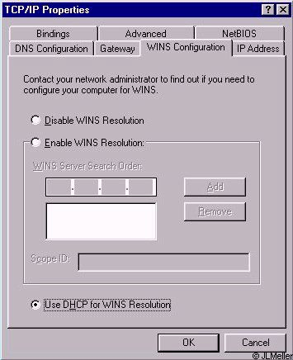
Gateway Tab – On this tab Installed gateways needs to be blank. If it is not Have the guest copy down what the address are and then remove them.

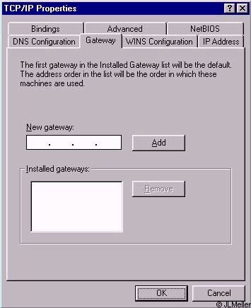

DNS Configuration Tab

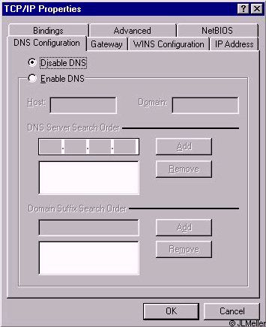
Bindings Tab

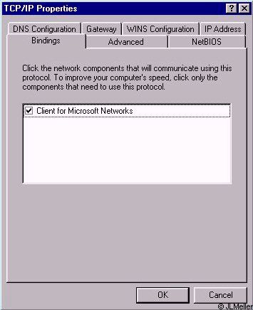

Advanced Tab

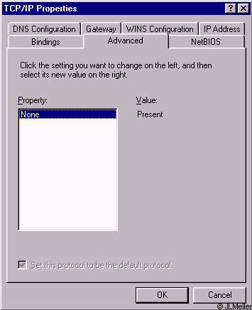
NetBIOS Tab

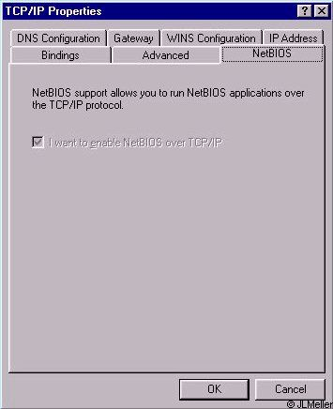

Windows 2000
Once again you go to Start>Settings>Control Panel. Once there go to Network and Dial up connections.
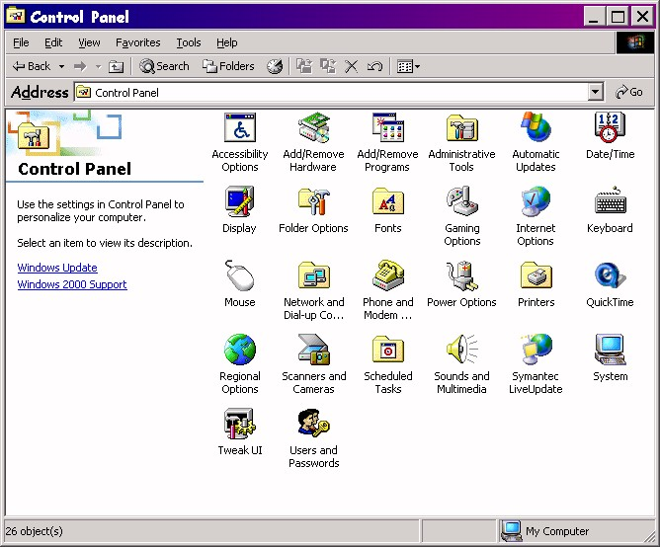
Once in Network and Dial up connections you find the local area connection that applies to the type of connection that you are working with (IE Wired or Wireless).
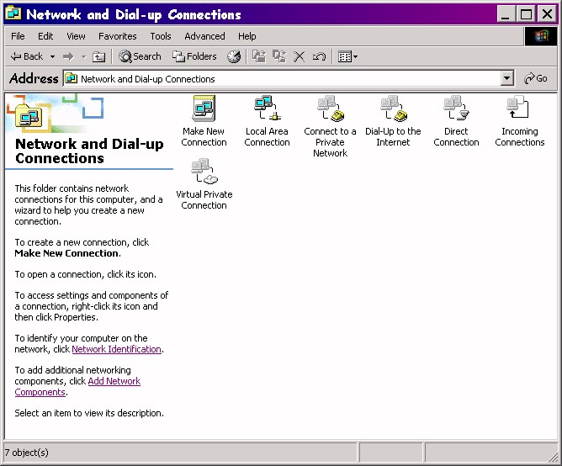

Once you have found the local area connection that is for the connection that the guest is using then right click on it and go to properties.
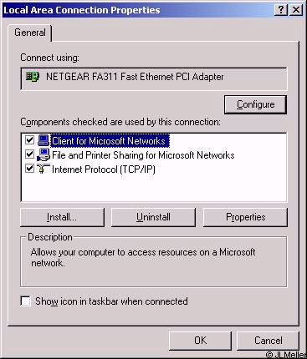
Now highlight TCP/IP and go to properties.
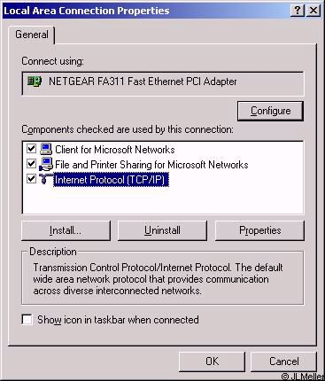

TCP/IP Properties.
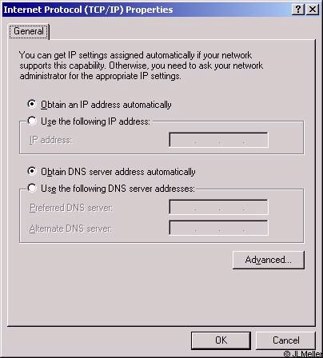
Now with Windows 2k and XP it is set up differently. Obtain and IP address automatically and Obtain a DNS server automatically need to be checked. If the guest is set for Use the following IP address then before changing it to the correct settings you need to make sure that they write down what information is in the boxes shown.

Advanced

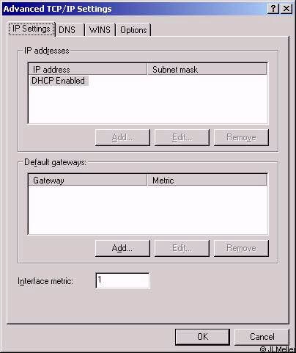

DHCP had to be enabled.

DNS Tab

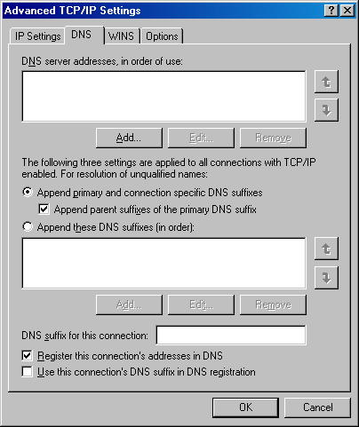

The settings on the guest computer should look like this. If there is anything set differently than what you see on the above screen you need to have the guest write down what the settings are and then set it to the default configuration that you see above.

Windows XP
Start>Settings>Control Panel. 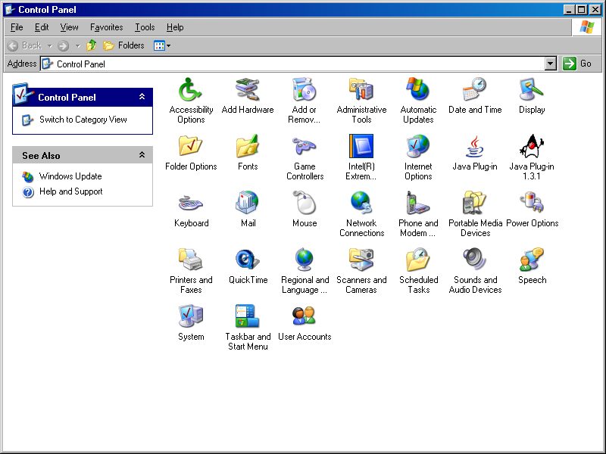
In XP you need to go to the network connections.
Network connections.
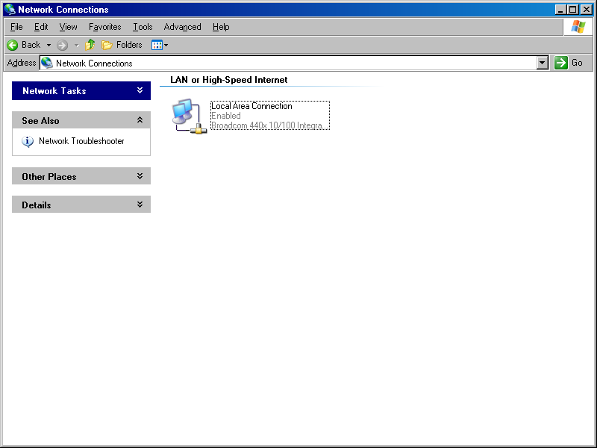
*If the connection you are using at the hotel is wireless you need to find the Wireless connection right click on it and go to properties.
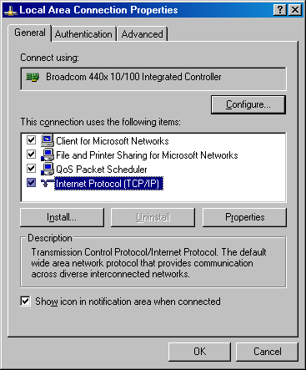
Once again highlight TCP/IP and then go to properties.
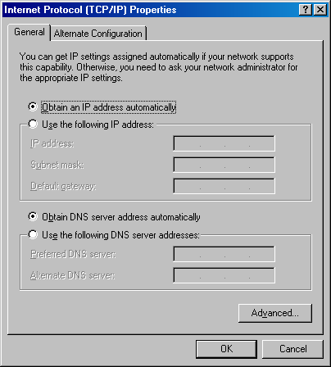
All the other setting on XP will need to be se the same way that Windows 2000 is set up.

